### **Lab 7 - React Forms and Redux**

### 9 PM +07

#### **Instructions**

In this assignment you will be updating the React application with a react-redux-form based local form and do the form validation in code.

**Assignment Overview**

In this assignment you will update the DishdetailComponent.js to include a form and do the form validation in code. At the end of this assignment, you should have completed the following tasks to update the page:

* Added a new class component named CommentForm to DishdetailComponent.js.
* Provide a form to enable users to submit their comments
* Validate the information entered by the users in the form

**Assignment Requirements**

**Task 1**

In this task you will add a new class component named CommentForm. You need to complete the following:

* Add a new class component named CommentForm that will add a button to the view as shown in the image below.
* When the button is clicked, it toggles a modal that will display the comment form.
* The CommentForm component is used by the RenderComments function to display the button for toggling the modal.

**Task 2**

In this task you will construct the form for users to submit their comments as shown in the image below. You need to complete the following:

* Set up the form as a local form using the react-redux-form with the three fields: author, rating and comment.
* The rating field in the comment form is implemented using a select, the author is implemented using a text field, while the comment uses a textarea with six rows.

**Task 3**

In this task, you will enable form validation as shown in the images below. You need to complete the following:

* The author field should at least be three characters long.
* The author field should be less than or equal to 15 characters.
* The user should be alerted by showing the invalid message displayed at the bottom of the field.

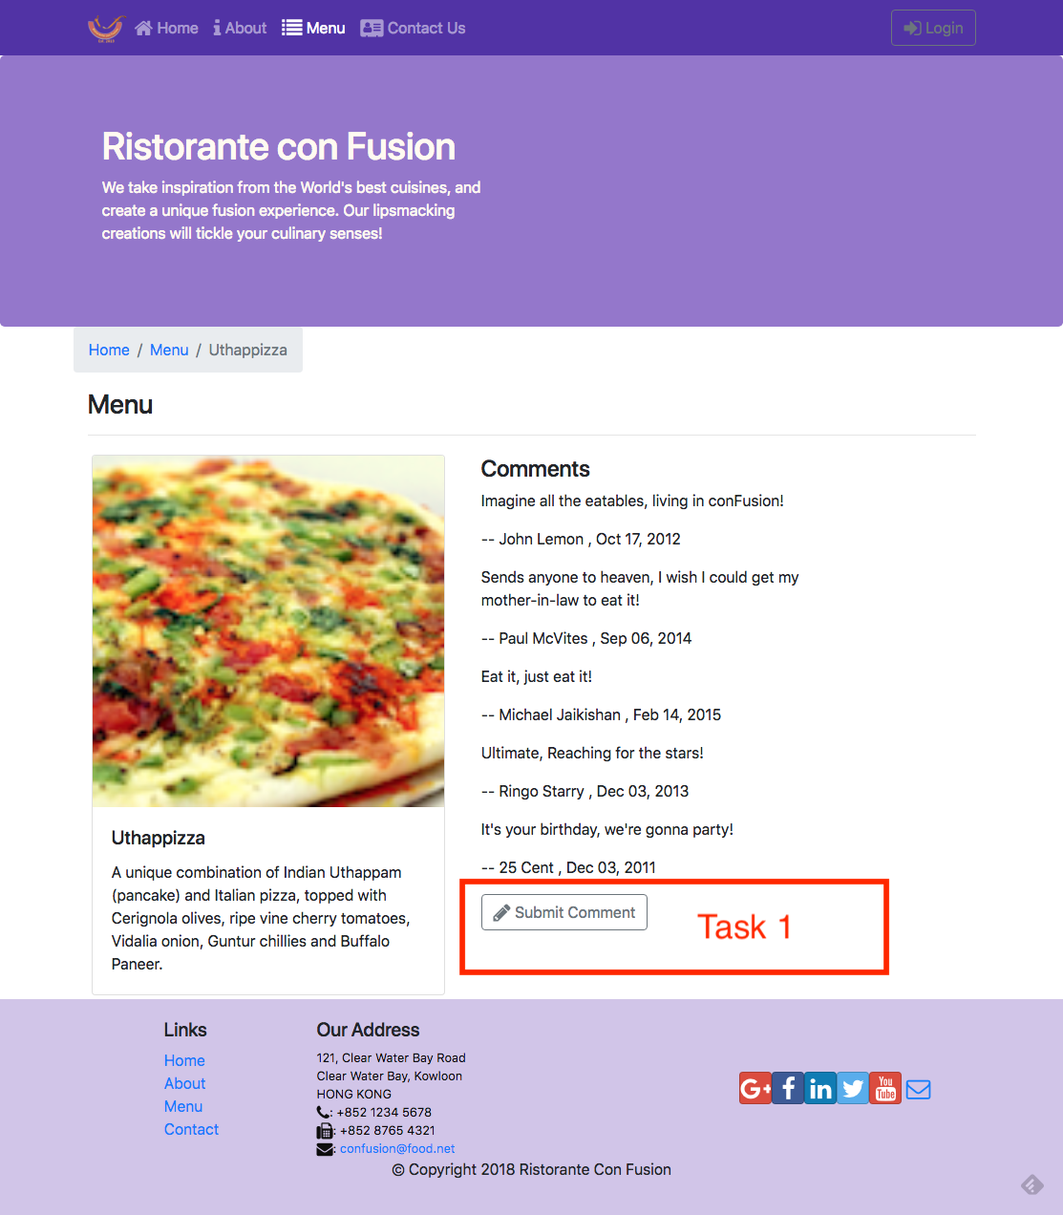

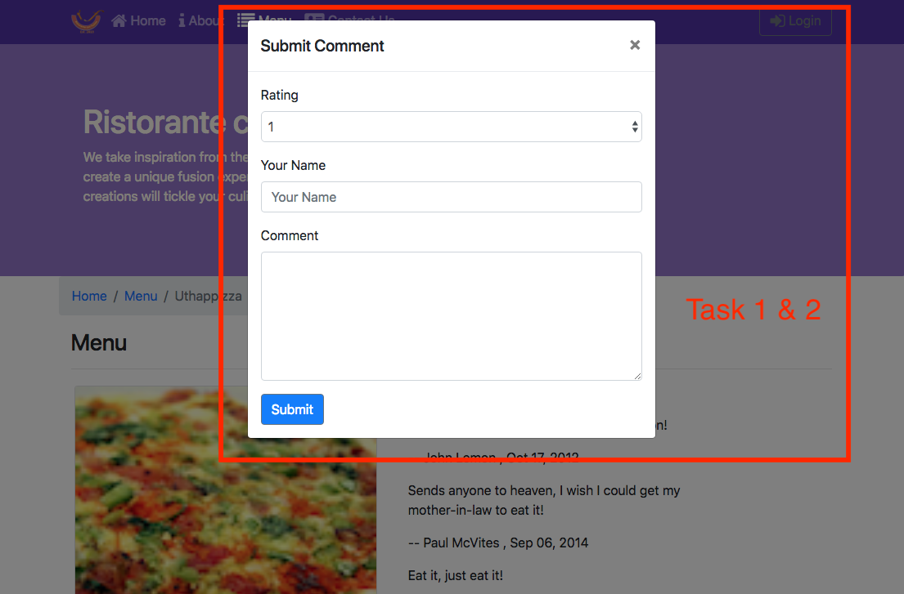

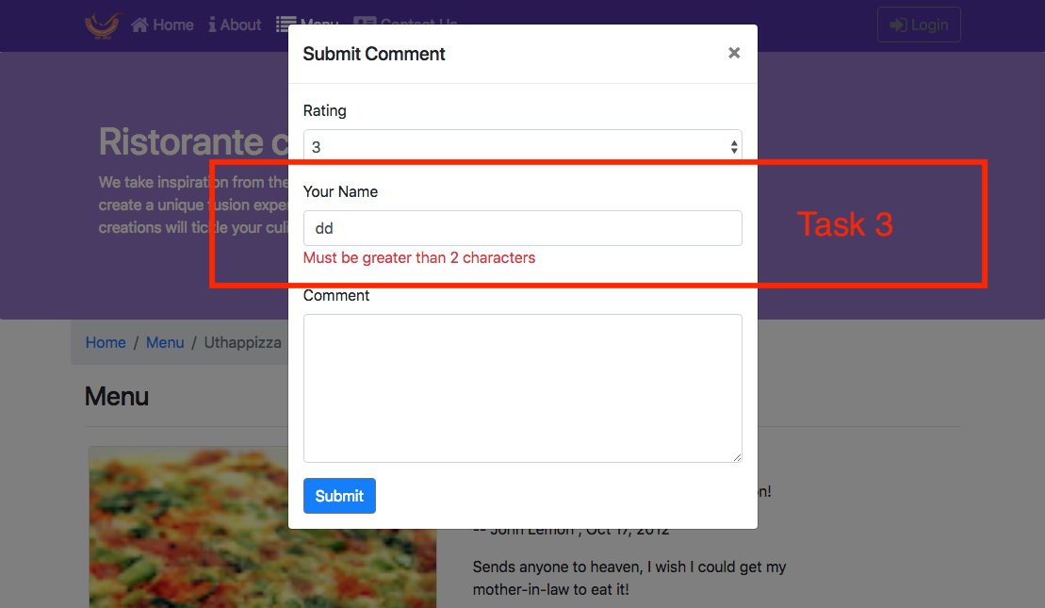

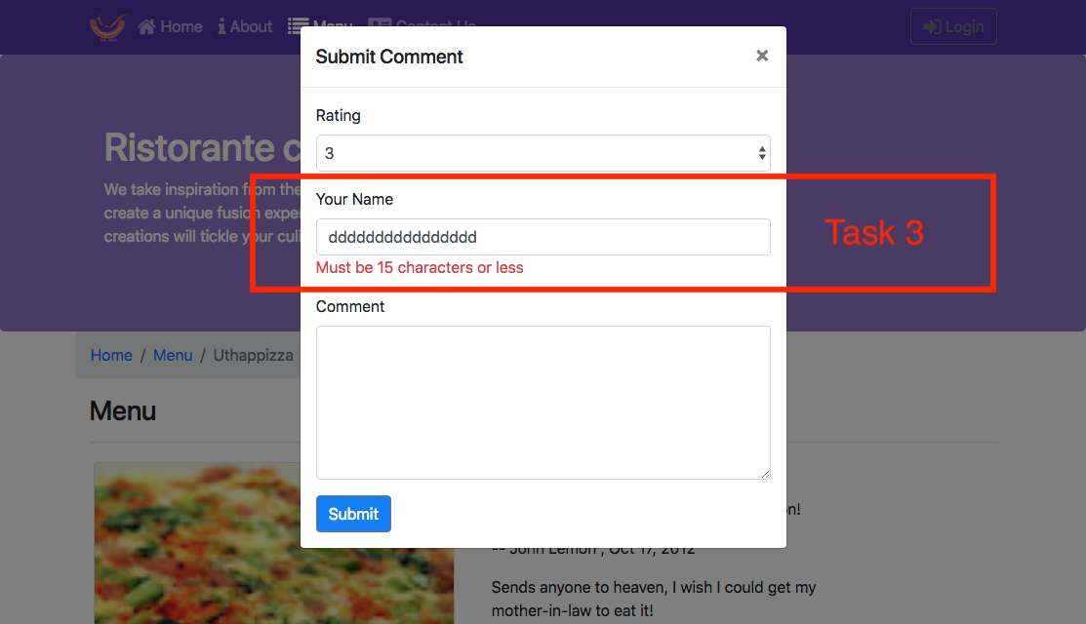

#### **Review criteria**

Upon completion of the assignment, your submission will be reviewed based on the following criteria:

**Task 1:**

* A CommentForm component is implemented that adds a button to the view, which when clicked will toggle a modal containing the form.

**Task 2:**

* The form is set up with the three fields correctly.
* A select is included in the form to enable users to submit the rating, a text field for author and a text area for the comment.

**Task 3:**

### The author field is being properly validated. If incorrect, the user is alerted.